

**SYNOPSIS HTML**

**K19SJ**

|  |  |  |  |
| --- | --- | --- | --- |
| **S.no** | **Registration no.** | **Name** | **Roll no** |
| 1 | 11904903 | Sagala Venkata Naga Vivek | RK19SJA22 |
| 2 | 11902504 | Sanam Venkata Vamsi | RK19SJA23 |
| 3 | 11903171 | Vayalathota Likith Sai | RK19SJA24 |

**INTRODUCTION**

**Websites:**

A website is a group of web pages that have information in the various pages that contain similar subject materials. For instance, the web site would have a name (subject) such as GoodFords.com and have several pages related to good Ford vehicles. The website has a main web page commonly called the Homepage (index.html or default.html). The site's address will display the homepage and you can click on hyperlinks to go to other pages on the website.

A webpage is a text page written in a form of HTML (Hypertext Markup Language) that contains text, links or tags that will display graphics, audio, video, downloadable files and of course other web pages.

**HTML:**

**Hypertext Markup Language** (**HTML**) is the standard [markup language](https://en.wikipedia.org/wiki/Markup_language) for documents designed to be displayed in a [web browser](https://en.wikipedia.org/wiki/Web_browser). It can be assisted by technologies such as [Cascading Style Sheets](https://en.wikipedia.org/wiki/Cascading_Style_Sheets) (CSS) and [scripting languages](https://en.wikipedia.org/wiki/Scripting_language) such as [JavaScript](https://en.wikipedia.org/wiki/JavaScript).

[Web browsers](https://en.wikipedia.org/wiki/Web_browser) receive HTML documents from a [web server](https://en.wikipedia.org/wiki/Web_server) or from local storage and [render](https://en.wikipedia.org/wiki/Browser_engine) the documents into multimedia web pages. HTML describes the structure of a web page [semantically](https://en.wikipedia.org/wiki/Semantic_Web) and originally included cues for the appearance of the document.

[HTML elements](https://en.wikipedia.org/wiki/HTML_element) are the building blocks of HTML pages. With HTML constructs, [images](https://en.wikipedia.org/wiki/HTML_element#Images_and_objects) and other objects such as [interactive forms](https://en.wikipedia.org/wiki/Fieldset) may be embedded into the rendered page. HTML provides a means to create [structured documents](https://en.wikipedia.org/wiki/Structured_document) by denoting structural [semantics](https://en.wikipedia.org/wiki/Semantics) for text such as headings, paragraphs, lists, [links](https://en.wikipedia.org/wiki/Hyperlink), quotes and other items. HTML elements are delineated by *tags*, written using [angle brackets](https://en.wikipedia.org/wiki/Bracket#Angle_brackets).

**CSS**

• CSS means Cascading Style Sheets. CSS was created to simplify the process of designing and presenting web pages. It is an easy-to-learn design language that offers powerful control over the presentation of HTML documents.

• CSS lets you save time. You can write one style sheet and define a style for each element and apply it to several HTML pages.

• Faster loading time. If you’re using CSS, you need not create HTML tag attributes all the time. You just have to write a CSS style for a tag and apply it to each occurrence of that tag. This means less code which translates to faster loading time.

**DESCRIPTION**

**Learning Management system website:**

A Learning Management System is a software-based platform that facilitates the management, delivery, and measurement of an organization’s corporate e-learning programs. The powerhouse of a complete learning technology solution, an LMS is a fundamental component of an effective learning strategy.

Learning management systems are used to deploy a variety of learning strategies across different formats, including formal, experiential and social learning to manage functions such as compliance training, certification management and sales enablement. E-learning has also evolved into a revenue generator for the [extended enterprise](https://www.docebo.com/enterprise-lms-corporate-learning-management-system/).

But it doesn’t stop there.

New advancements in learning technology have helped to support evolving learner needs and revolutionize the e-learning space. LMSs now provide improved data collection activities and support activities such as [mobile learning](https://www.docebo.com/mobile-learning-lms-app-elearning-platform/) and [gamification](https://www.docebo.com/gamification-elearning/) to help achieve greater engagement, boost productivity and promote continuous learning and upskilling.

Online learning platforms, such as Docebo, go beyond basic LMS functionality by incorporating [social learning](https://www.docebo.com/corporate-lms-formal-informal-social-learning/) features into the platform and [leveraging Artificial Intelligence (AI)](https://www.docebo.com/blog/ai-lms-learning-technology/). Sophisticated AI technology grows to understand each learner’s behaviour, creating unique, personalized learning experiences, and social learning lets learners consult peer mentors, ask questions, and collaborate.

**What is an LMS Used For?**

At a very basic level, learning management systems centralize, deploy, and measure learning activities. A state-of-the-art learning management system supports a variety of internal and external corporate use cases, including:

[**Employee Onboarding**](https://www.docebo.com/docebo-ai-lms-employee-onboarding/)**:** Perhaps the most common LMS use case is to support new employees with their initial onboarding. Bring newcomers up-to-speed on your company’s learning culture by providing them opportunities to consume relevant materials across multiple devices, contribute their own knowledge, and be recognized for it.

[**Employee Development and Retention**](https://www.docebo.com/docebo-ai-lms-employee-development-platform/)**:** Another common LMS use case is to support the [training and development of current employees](https://financesonline.com/best-employee-development-methods/). Within the LMS, courses can be assigned to ensure employees acquire the right job skills, are informed about product changes, are up-to-date on compliance training, etc.

[**Compliance Training**](https://www.docebo.com/docebo-ai-lms-compliance-training-learning-platform/)**:** An LMS can also be used to make sure employees receive any mandated training and manage recurring certification and training programs. This centralized approach mitigates risk and helps to avoid any potential regulatory compliance issues.

[**Sales Enablement**](https://www.docebo.com/docebo-ai-lms-sales-enablement-learning-platform/)**:**An LMS is also central to enabling sales at scale by preparing salespeople with the knowledge they need, exactly when they need it. The platform also speeds up onboarding so that new hires can start selling sooner, and ensures that you retain your top performers.

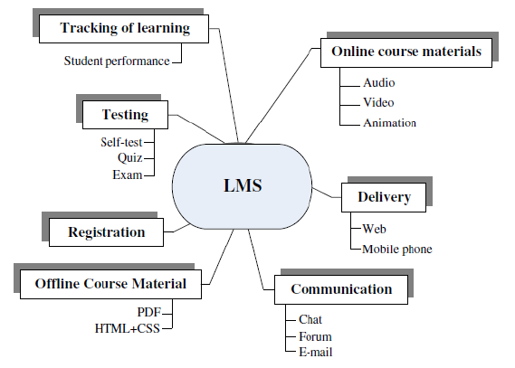

#### ****What are the advantages of an LMS?****

There are many benefits and advantages to both businesses and their learners when [implementing an LMS](https://www.docebo.com/lms-implementation-journey/).

**Top Benefits:**

* [Reduce learning and development costs](https://www.docebo.com/blog/learning-development-strategic-partners-upskilling-reskilling/)
* [Cut down training/onboarding time for employees, customers, and partners](https://www.docebo.com/blog/future-proof-business-upskilling-reskilling-workforce/)
* [Leverage AI to free-up time for L&D administrators](https://www.docebo.com/blog/learning-development-ai-technology/)
* [Maintain compliance](https://www.docebo.com/resource/city-of-kingston-compliance-training-docebo-case-study/)
* Track learner progress
* [Measure how learning impacts organizational performance](https://www.docebo.com/blog/measure-learning-impact-docebo-formetris/)

**Top Benefits for Learners:**

* [Increase knowledge retention](https://www.docebo.com/blog/employee-knowledge-retention-lms/)
* Acquire skills and knowledge required for career advancement
* Improve performance

**How can we use this LMS?**

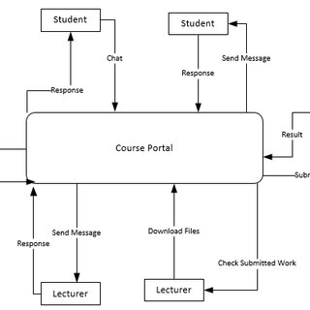

**TAGS USED FOR THIS WEBSITE:**

|  |  |
| --- | --- |
| **HTML Tags** | **Description** |
| **<html> </html>** | **HTML document indicates** |
| **<head> </head>** | **Head portion of the program indicates** |
| **<title> </title>** | **Document titles indicate** |
| **<body> </body>** | **Main content portion of the program indicates.** |
| **<a> </a>** | **Anchor tag** |
| **<b> </b>** | **Bold indicates text** |
| **<i> </i>** | **Italic refers to the text** |
| **<big> </big>** | **Specifies the text larger than usual** |
| **<small> </small>** | **Indicates text smaller than usual** |
| **<br> </br>** | **Create a line break** |
| **<code> </code>** | **Computer code reveals the text** |
| **<table> </table>** | **Table is used to make** |
| **<col> </col>** | **Used to create table columns** |
| **<td> </td>** | **Table is used to make the cell** |
| **<tr> </tr>** | **Table row is used to make** |
| **<h1> </h1>** | **Header tag is up to 1-6** |
| **<hr> </hr>** | **Create parallel lines** |
| **<img> </img>** | **Used to add pictures** |
| **<input> </input>** | **Form input field Is used to create** |
| **<li> </li>** | **Used to create lists** |
| **<meta> </meta>** | **Meta tag** |
| **<ol> </ol>** | **Order is used to create a catalog** |
| **<ul> </ul>** | **Unorders are used to create lists** |
| **<pre> </pre>** | **Used to create pre-formatted text** |

Flow Chart:

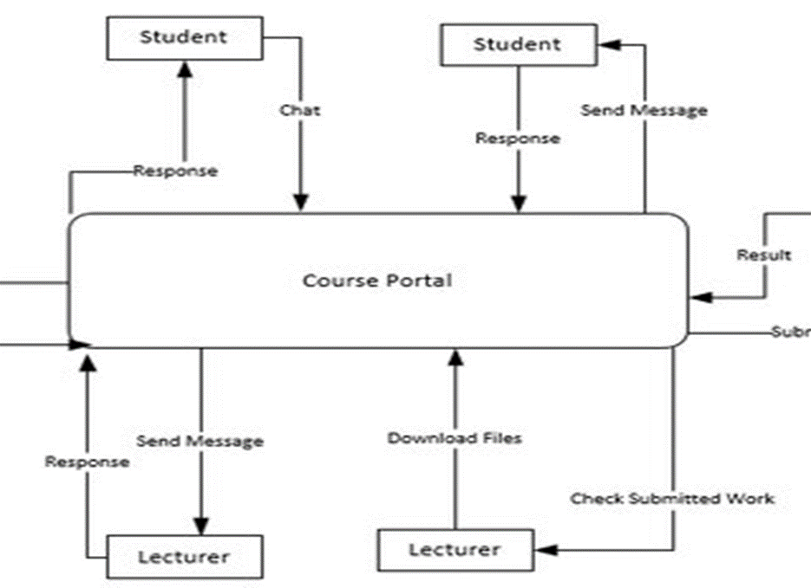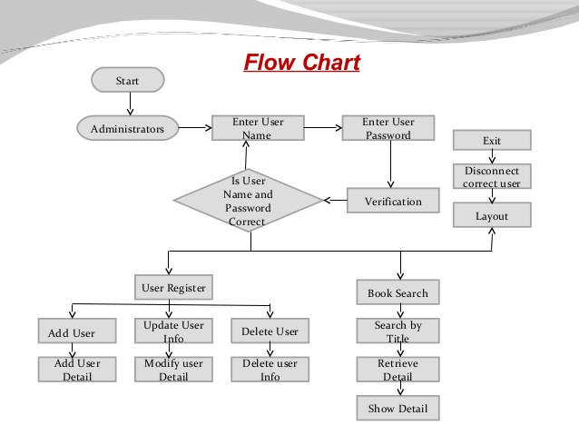**CONCLUSION**

**Firstly, it streamlines the education process. Marking work is easier and quicker, especially with self-marking quizzes and tests. Plus, as we’ve mentioned above, messages, work setting and submission, and results are now all in one place.**

**Technology has the potential to engage and motivate learners more than ever before – and with an intuitive learning management system, you could see interaction and subsequently results improve. In particular, features that motivate learners, incentivize achievement and can make learning fun.**

**REFERENCES**

* [**https://en.wikipedia.org/wiki/Learning_management_system**](https://en.wikipedia.org/wiki/Learning_management_system)
* [**http://edutechwiki.unige.ch/en/Learning_management_system**](http://edutechwiki.unige.ch/en/Learning_management_system)
* [**https://link.springer.com/10.1007%2F978-1-4419-1428-6_187**](https://link.springer.com/10.1007%2F978-1-4419-1428-6_187)

